Choice Based Lettings Scheme
MONTPELIER, DUBLIN 7
Eligible applicants can apply for 1 x 2 Bedroom Apartment & 7 x3 Bedroom Apartments
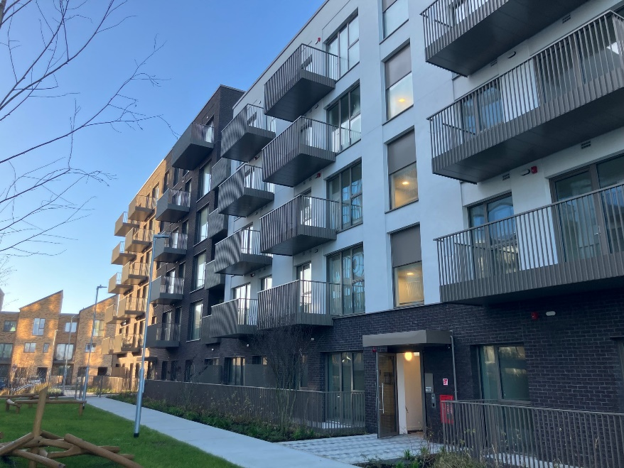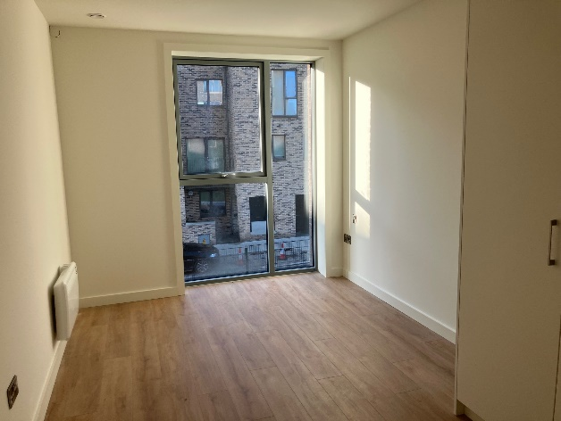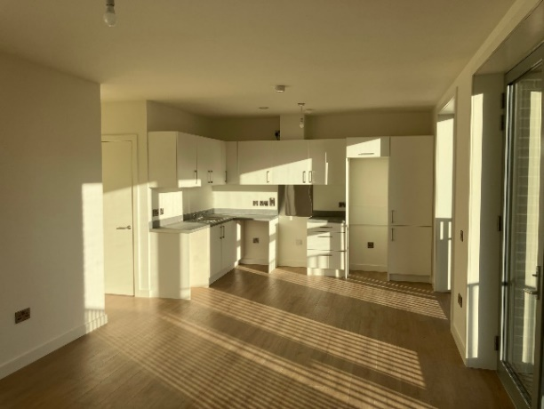
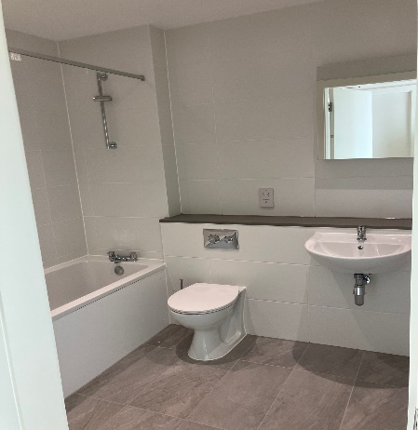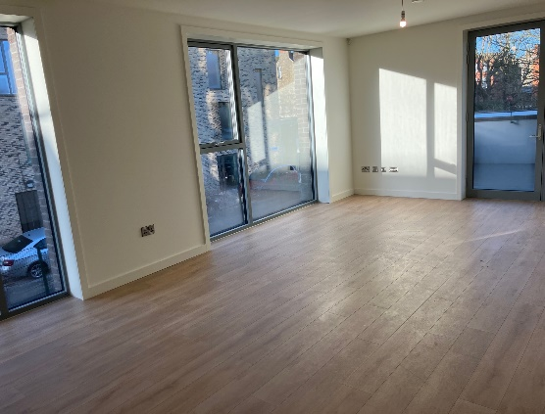

This development is managed by TUATH Housing.
Dublin City Council is inviting eligible applicants from all of our waiting lists who have selected Area P as their area of preference to apply for the above properties.
Montpelier forms part of one of Europe’s most sustainable and ambitious residential regeneration projects, situated on the site of the former O’ Devaney Gardens in Dublin 7.
The development is located off the North Circular Road, in close proximity to the Phoenix Park. Getting around is effortless — with Heuston Station just minutes away, the Luas Red Line within walking distance and easy access to major bus and bike routes, your daily commute or weekend adventure is always within reach. Spend your free time exploring the vast greenery of Phoenix Park, grab a coffee in one of Stoneybatter’s many cafés, or catch a gig, exhibition or pint just a short stroll into the heart of Dublin city centre. Whether it’s food, culture, nightlife or connectivity, Montpelier gives you a lifestyle that’s fast-paced, full of choice and totally city centred all while having nature and history at your fingertips.
TUATH will issue tenants with details of house rules which outlines the expectations tenants will need to agree to as part of the tenancy agreement.

- Parking not provided
- Furnishings and white goods are not included

Start date for applications is Friday December 19th 2025
Closing date for applications is Friday January 9th 2026

- All Applicants must be listed for Area P. Do not apply if you do not have Area P as a preference.

- This application form can be completed online :www.dublincity.ie/Choice Based Lettings or can be returned to : 97 New Cabra Road, Cabra, Dublin 7

- As the final offer is made to the applicant in the highest position, there is no supporting documentation required as only position on your waiting list is considered.

- All applications will be examined on estate management grounds including rent arrears.

- A successful applicant who refuses a Choice Based Letting will not be eligible for consideration for another Choice Based Letting Unit for a period of one year.

- Start date of CBL advertisement is 19th December 2025, End date 9th January 2026 at 5pm.

- Please note late applications will not be considered.

- As per your Social Housing Application form, Dublin City Council will process your Choice Based Letting application in line with GDPR Guidelines. Please see Dublin City Council Privacy Statement on Dublin City Council website.

Application Form

Name _______________________________

Address _______________________________

_______________________________

PPSN _______________________________

Family Size ______________________________

Housing Reference Number ______________________________

Telephone/ Mobile Number ______________________________

Email address ______________________________

Applying for: Two Bed _____ Three Bed ____

Did you read/understand the procedures above: Yes______ No _____

Signature ______________________________

